**How to use Alteryx for Tableau**

**Summary:**

In context with tableau, the Alteryx is mainly used for the following mentioned purposes:

1. **Generate tde format file for Tableau**

In Tableau, for the better performance of dashboards, it is highly recommended to use tableau data extract file called as “tde” file. Using Alteryx, user can generate the tableau data extract file (“tde” file). This generated ‘tde” file can be directly used in tableau for creating charts.

**How to create tde file using Alteryx:**

1. Open ‘Alteryx Designer’ and “New Workflow1” workflow canvass will get created automatically

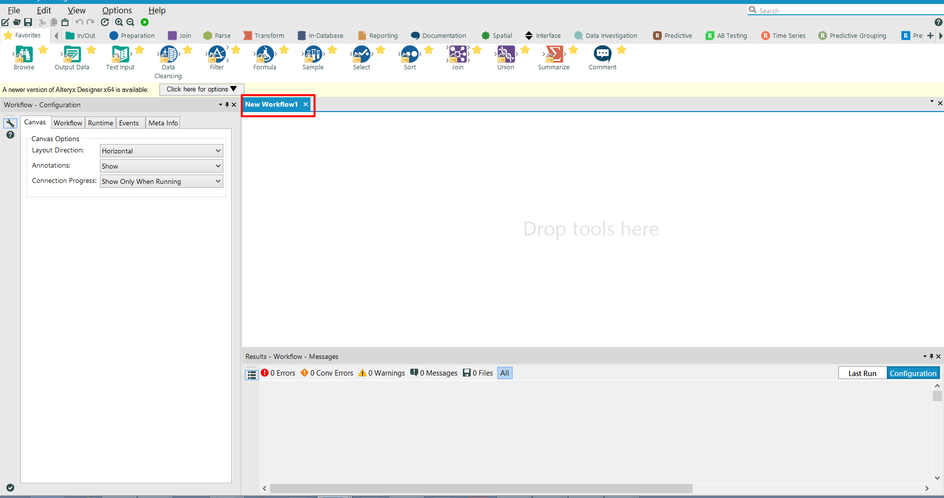

1. Now, drag the “Input Data” tool from above tool palette onto “New Workflow1” workflow canvass

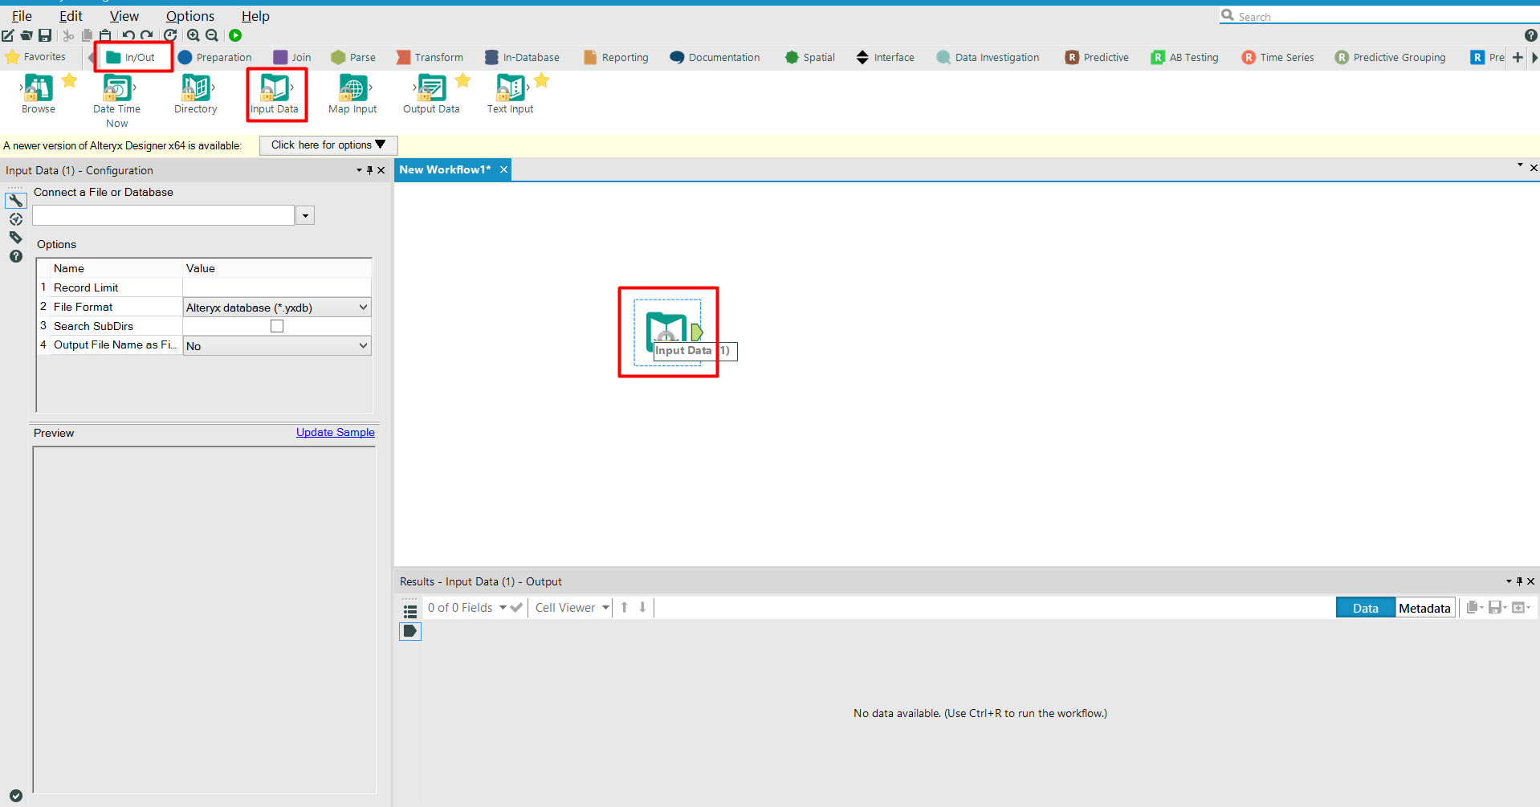

1. Connect to the input data source which you want to convert into “tde” file for tableau. In Alteryx, there are various options to connect to input data source like Excel, SQL, and Hadoop etc.

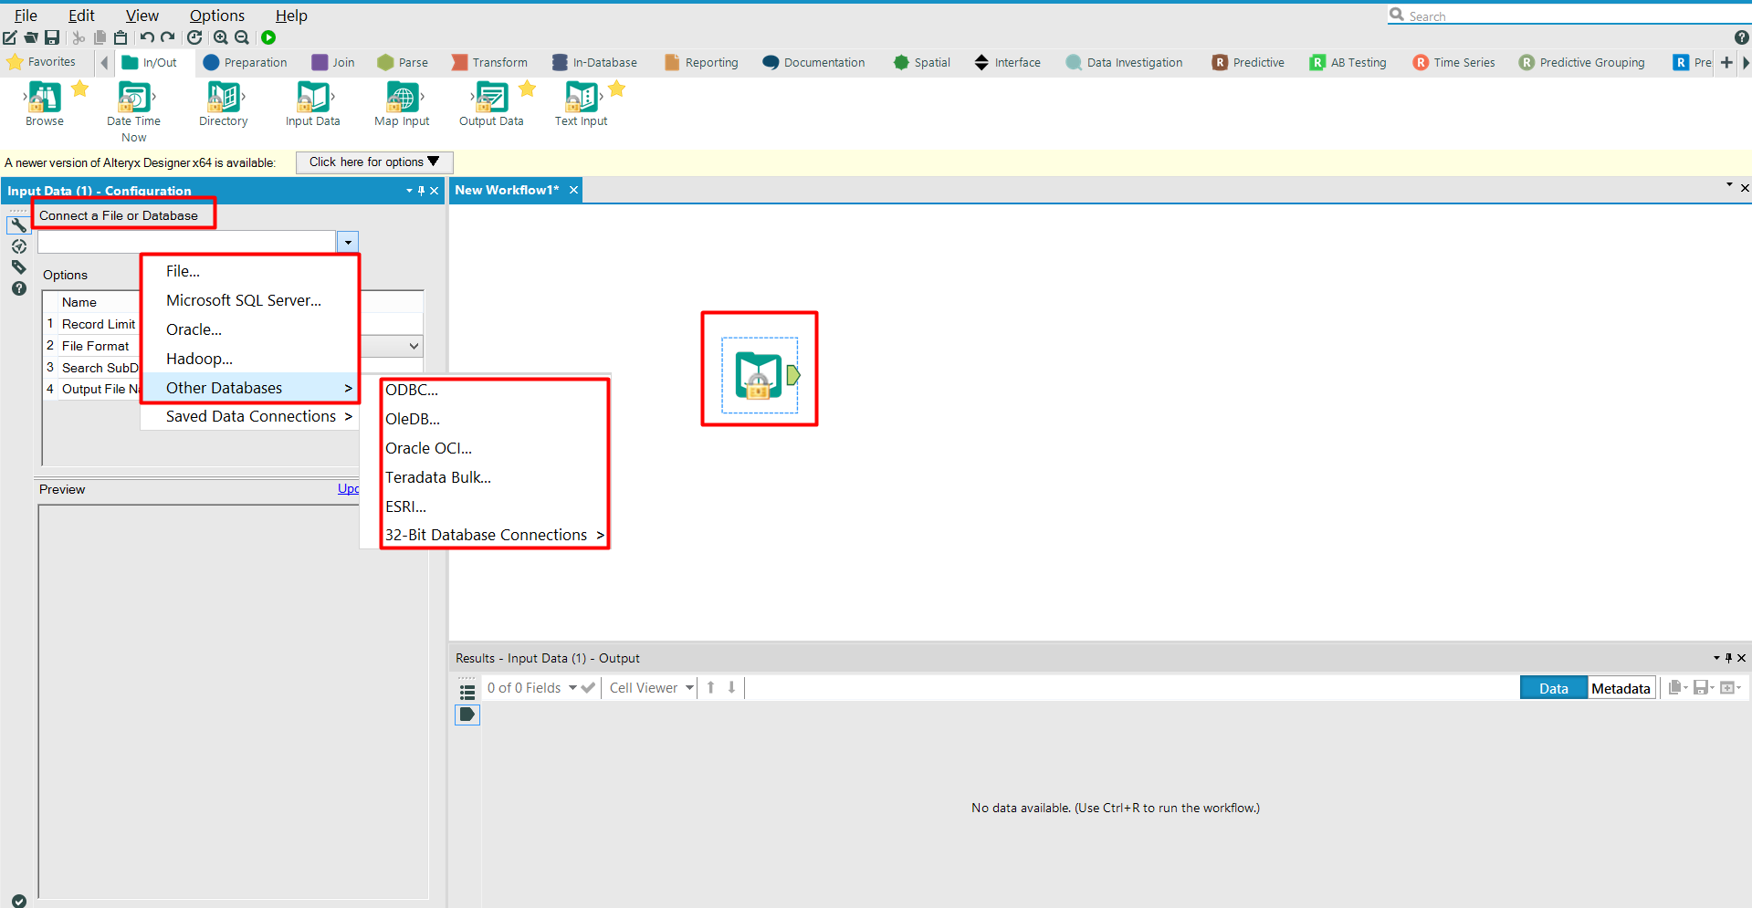

1. Now, drag the “Output Data” tool from above tool palette onto “New Workflow1” workflow canvass and make the connection between “Input Data” and “Output Data’ tools to complete the workflow

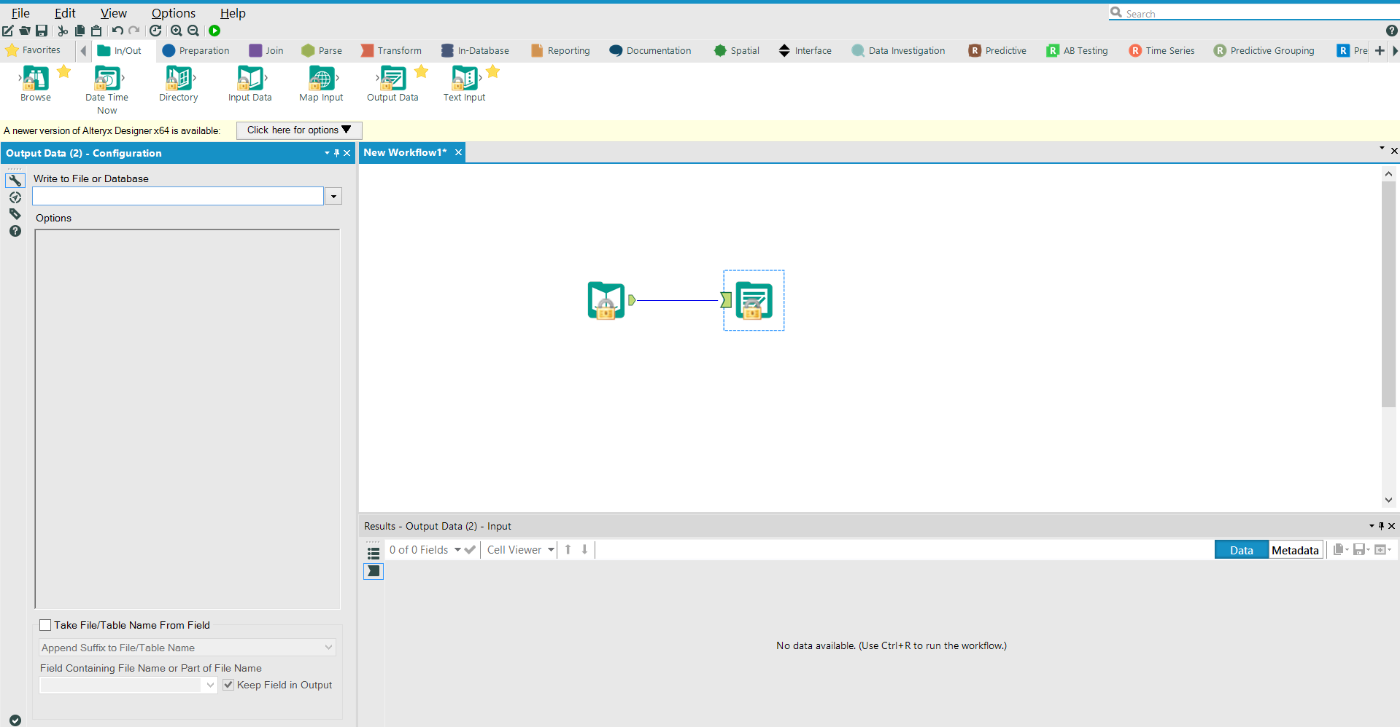

1. After making connection with the “Output Data” tool, provide the location and name to save the output tde file. While mentioning the name, in the “Save as type” option select *Tableau Data Extract (.tde)* .

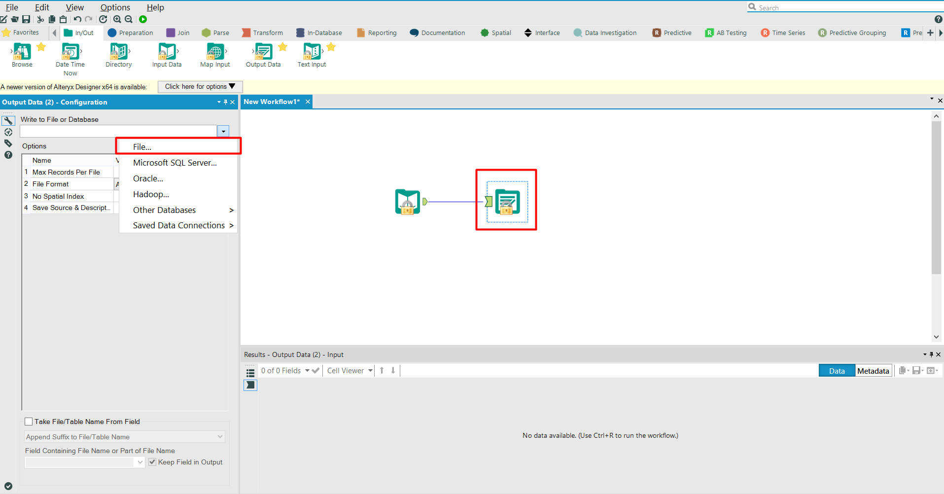

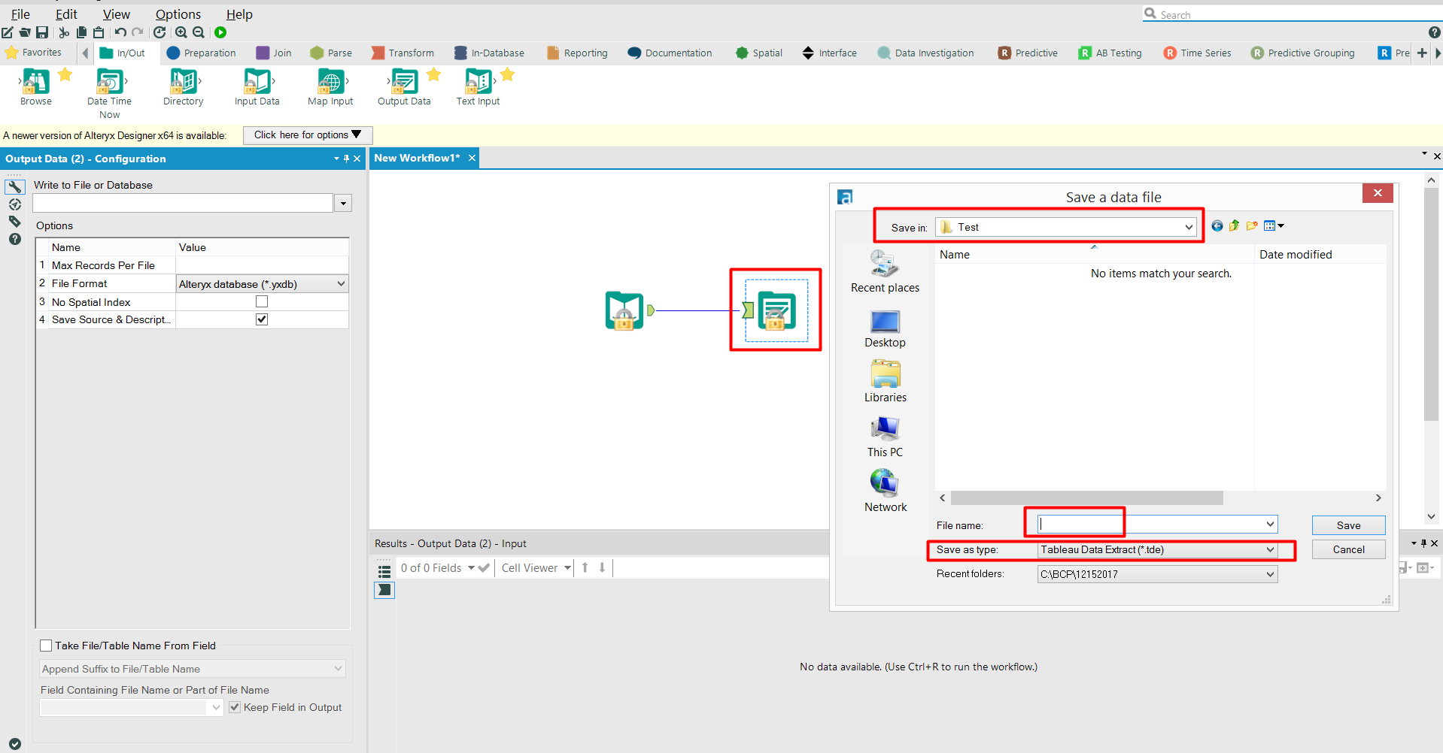

1. Now, run the workflow by clicking on the “Run” button at top

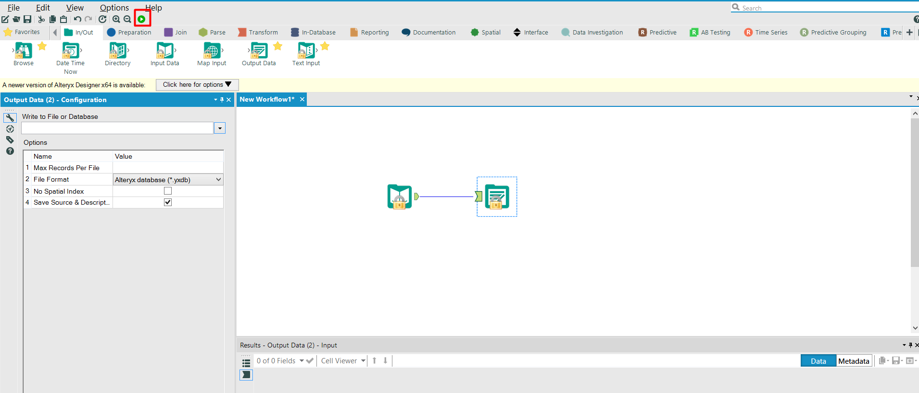

1. **Publish the data source on Tableau Server:**

Using Alteryx’s *“Publish to Tableau Server”* tool, user can publish the input data directly to tableau server.

This is very useful, when in tableau data connection is live and directly connected to tableau server. In those cases to update the data on tableau server, this tool can be used.

**How to publish the input data to tableau server using Alteryx:**

1. First, download the *“Publish to Tableau Server”* tool from: <https://gallery.alteryx.com/#>!
2. After downloading the tool, install it so that it can appear in tool palette of Alteryx
3. Open ‘Alteryx Designer’ and “New Workflow1” workflow canvass will get created automatically



1. Drag the “Input Data” tool from above tool palette onto “New Workflow1” workflow canvass



1. Connect to the input data source which you want to convert into “tde” file for tableau. In Alteryx, there are various options to connect to input data source like Excel, SQL, and Hadoop etc.



1. In the search bar on top right side corner, search for *“Publish to Tableau Server”* tool and drag it to canvass

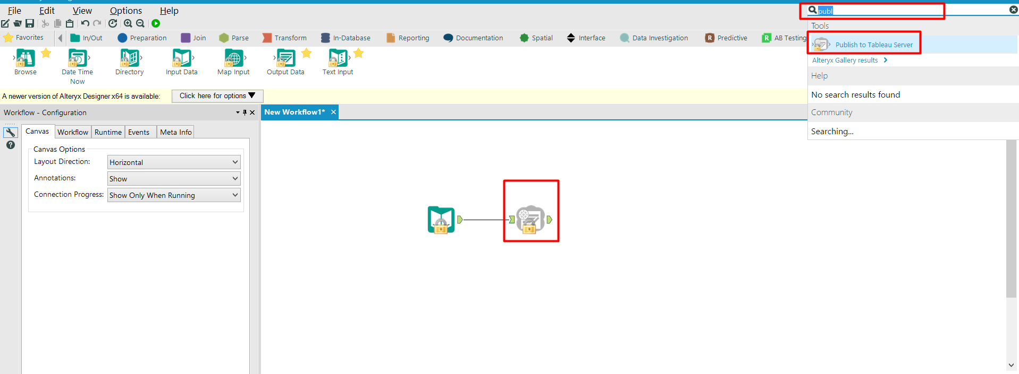

1. Make connection between the “Input Data” tool and “Publish to Tableau Server” tool
2. Select the “Publish to Tableau Server” tool and provide the following information:

* Server URL
* Site Name
* Username (of tableau server)
* Password (of tableau server)
* File name of publish data source
* Project Name (which is present at the tableau server site)

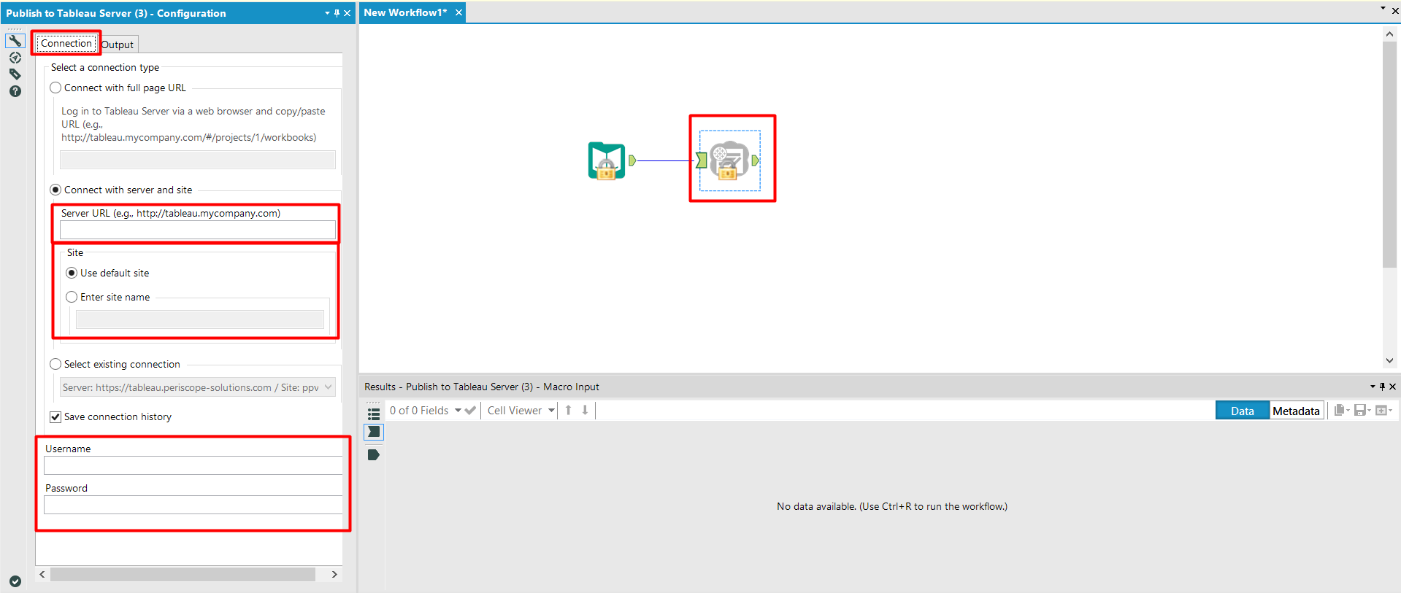

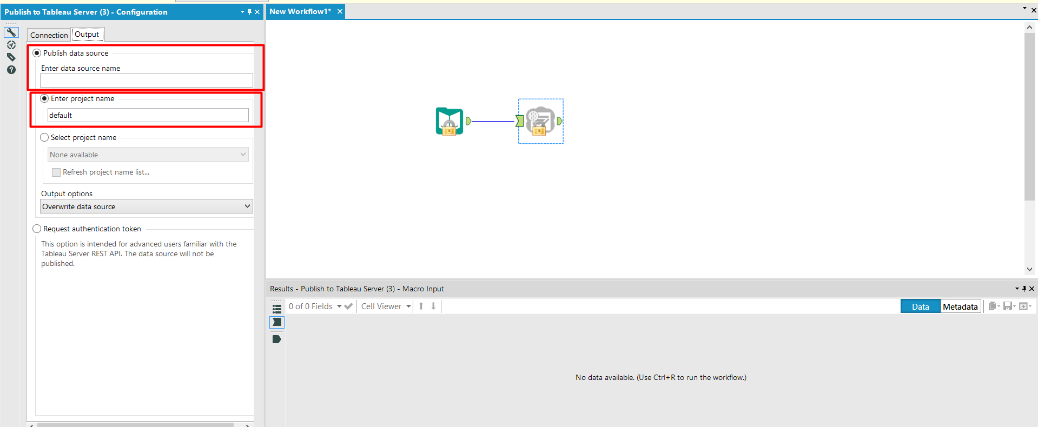

1. Now, run the workflow by clicking on the “Run” button at top

